**Course: IT4409E**

**Semester: 20222**

**WEEKLY EXERCISE**

**Notes**

* Create a folder for each week to store exercises, for example a Week 2 folder for Week 2’s requirements.
* Deadline for submission is 23:59' on Thursday of the following week.
* Members submit their own individual exercise, the group only needs to submit a result of the group exercise
* Individuals involved in fraud will receive the midterm grade of 0

**Week 2.**

**1. Group exercise:** creates Facebook Signup page and Google search page

Facebook Signup

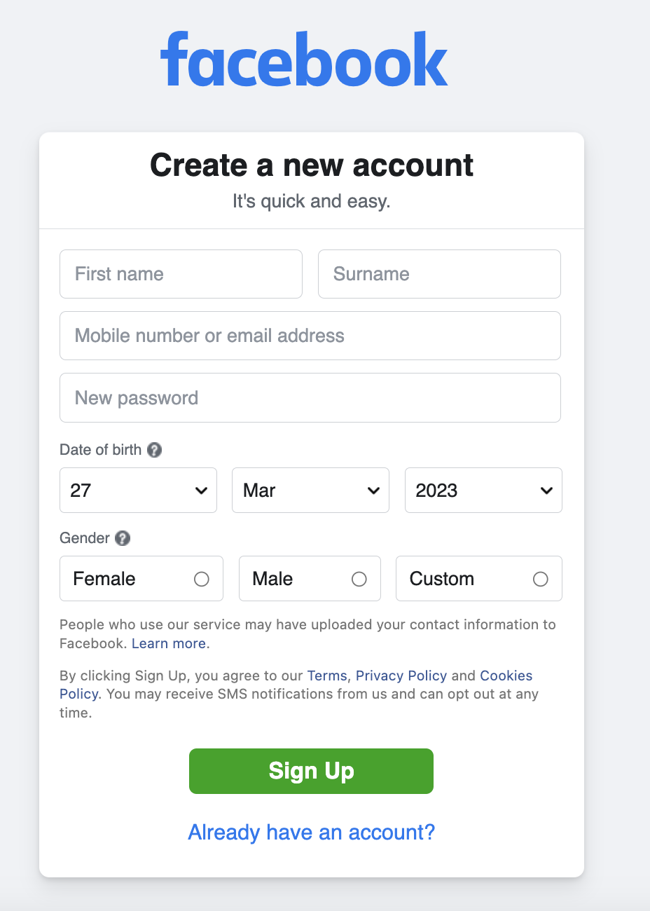

**Google:** https://www.google.com.vn/

**2. Individual exercise:** [https://www. w3schools.com/html/exercise.asp](https://www.w3schools.com/html/exercise.asp)

Complete 88 exercises.

Take a photo of the assignment. In the photo there is information about the number of exercises completed, date and time, and information about your computer. For example

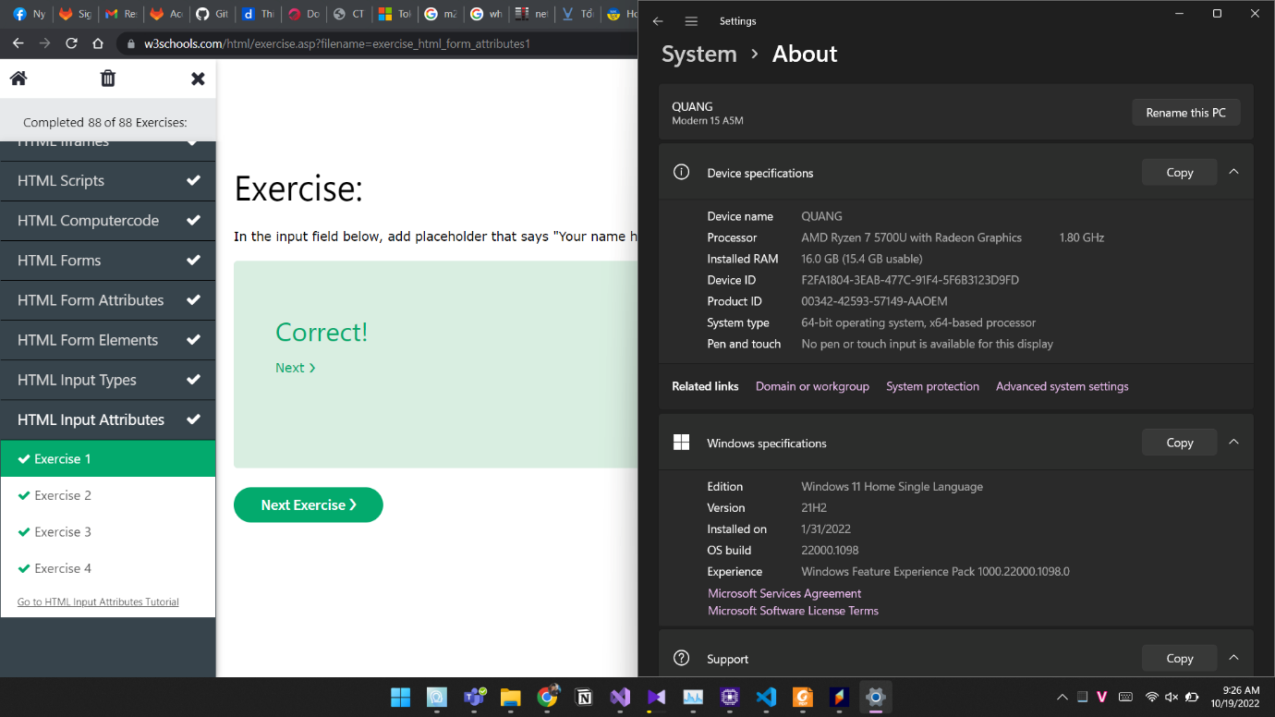

**Example about folder organization of Week 2**

